Communications-based train control

CBTC

**Introduction**

**CBTC** is a system used in communications between trains and track equipment to get a live information about the train such as location and speed.

IEEE defines CBTC as a continuous automatic train control system utilizing:

• High-resolution train location determination, independent of track circuits

• Continuous, high-capacity, two-way train-to-trackside data communications

• Train borne and trackside processors capable of performing essential functions

**System architecture**

The system is divided to three sections

**1- tags or beacons:**

Tags or beacons are installed along the track, they define the current location of the train. A Tachometer installed on the axles ~~count~~ measures how far the train is from the tags.

**2- Train unit:**

The train unit will receive the ID of tag and the distance between the train and the tag through the tachometer

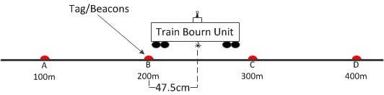

**3- Wayside unit:**

After the train unit ~~knows~~ detects the current location, it sends the information to an access point and then to wayside unit.

Every access point has a range, once the train will ~~be~~ is out of the predetermined range, it will disconnect from the access point and connect with the ~~new~~ next ~~other~~ access point

The way side units are connected together through a network

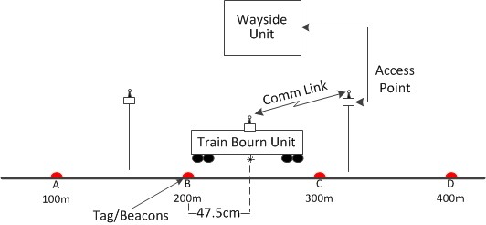

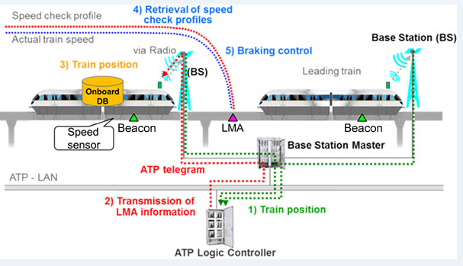

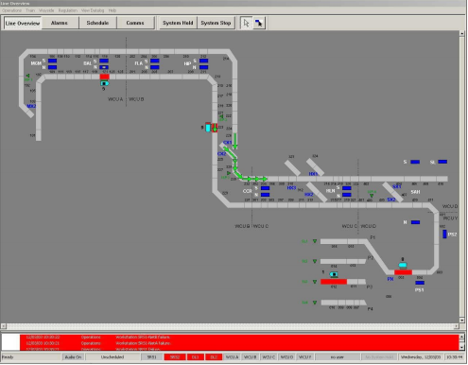

References :

<https://www.smartrailworld.com/expert-focus-what-is-communication-based-train-control-cbtc>

<http://www.hitachi-rail.com/products/signalling/cbtc/index.html>

<https://en.wikipedia.org/wiki/Communications-based_train_control>

<https://www.researchgate.net/publication/283187607_CBTC_Simulation_Platform_Design_and_Study/download>